Usage Instruction

1 Pre-use preparation

Please run this tool on windows10 or windows11

1-1 Install Java

The tool needs JDK 8java.png

1-2 AspectJ

Install AspectJ from

<https://www.eclipse.org/aspectj/downloads.php>

or in the files we provide.

(version is AspectJ 1.9.6, Released 22 Jul 2020)

After downloading, please configure the system variables.

In system variable's CLASSPATH, add

<AspectJ_HOME>/lib/aspectjrt.jar;

<AspectJ_HOME>/lib/aspectjweaver.jar;

<AspectJ_HOME>/lib/aspectjtools.jar

In system variable’s Path, add

<AspectJ_HOME>/bin

The <AspectJ_HOME> is your download address in your system

such as

CLASSPATH :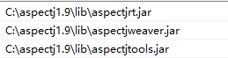

Path :屏幕截图 2022-11-22 143536.png

**1-3 RV-Monitor**

Install RV-Monitor from <https://www.runtimeverification.com/monitor>

Or in the files we provide.

(version is 1.3+)

After downloading, please configure the system variables.

In system variable's CLASSPATH, add

<RV-Monitor_HOME>/lib/rv-monitor.jar;

<RV-Monitor_HOME>/lib/rv-monitor-rt.jar

In system variable’s Path, add

<RV-Monitor_HOME>/bin

The < RV-Monitor_HOME> is your download address in your system

such as

CLASSPATH :屏幕截图 2022-11-22 143900.png

Path:屏幕截图 2022-11-22 143546.png

1-4 JavaMOP

Install RV-Monitor from <https://fsl.cs.illinois.edu/index/php/JavaMOP4>

Or in the files we provide.

In system variable's CLASSPATH, add

<JavaMOP_HOME>/bin

The <JavaMOP_HOME> is your download address in your system

such as

CLASSPATH :屏幕截图 2022-11-22 143554.png

1-5 Check Installation

Run cmd and input

Java -version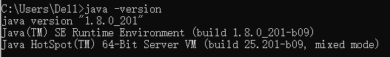

ajc -version屏幕截图 2022-11-22 144723.png

rv-monitor -version

javamop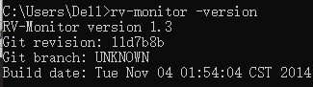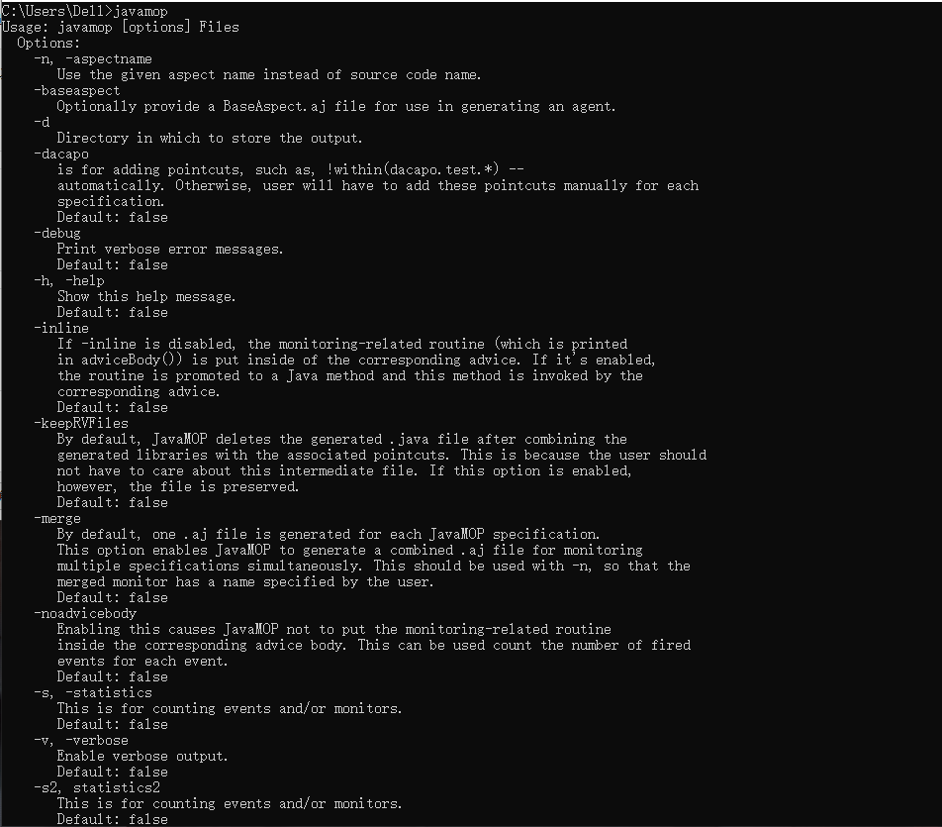

1-6 Install Python and Django

Our tool’s backend is running on Django and Python, so please make sure the version of python is 3.7+ and the python’s environment

The runtime ip and port is <http://127.0.0.1:8080/>

2 Tutorial

2-1 Start backend

Run the backend and it will show :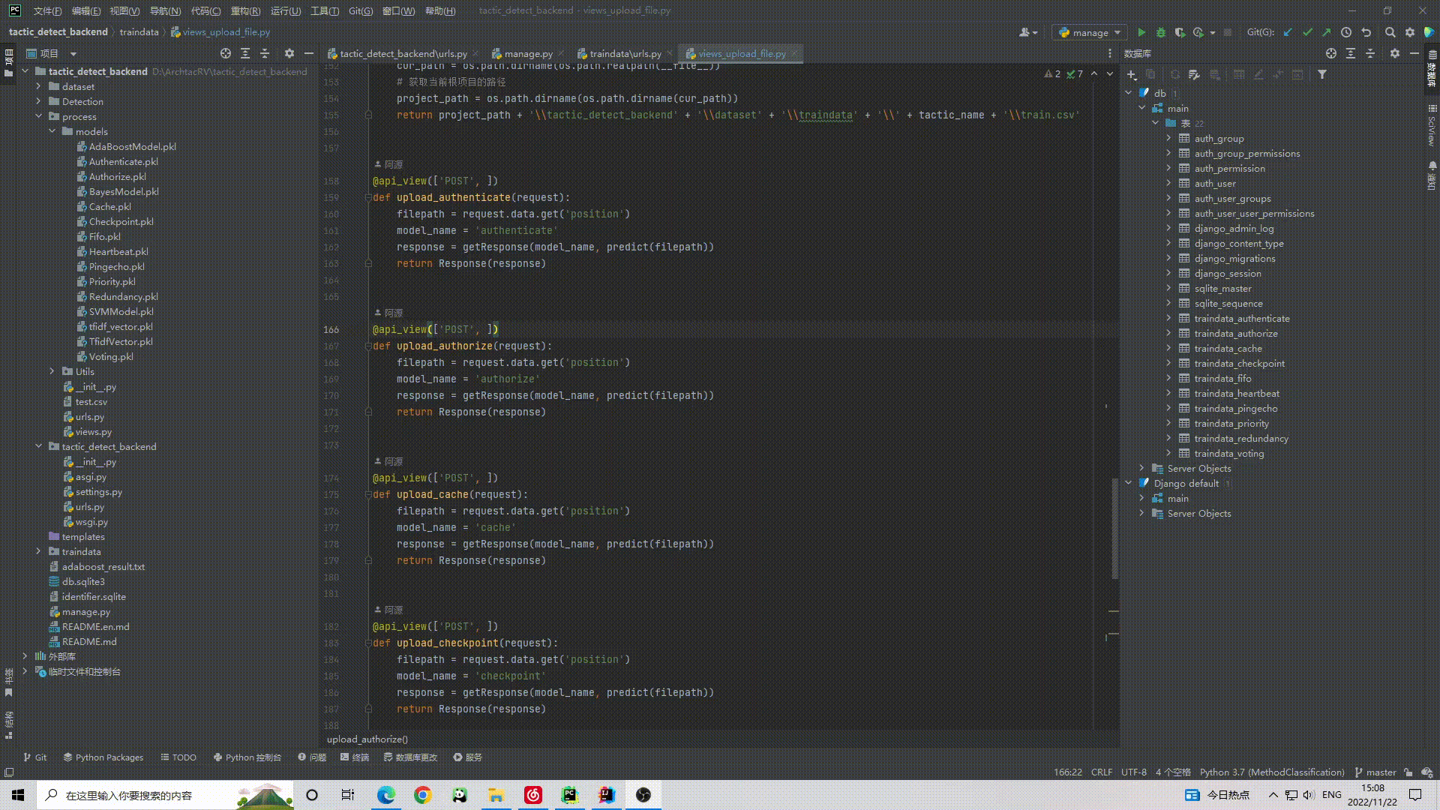

2-2 Start frontend

Run the 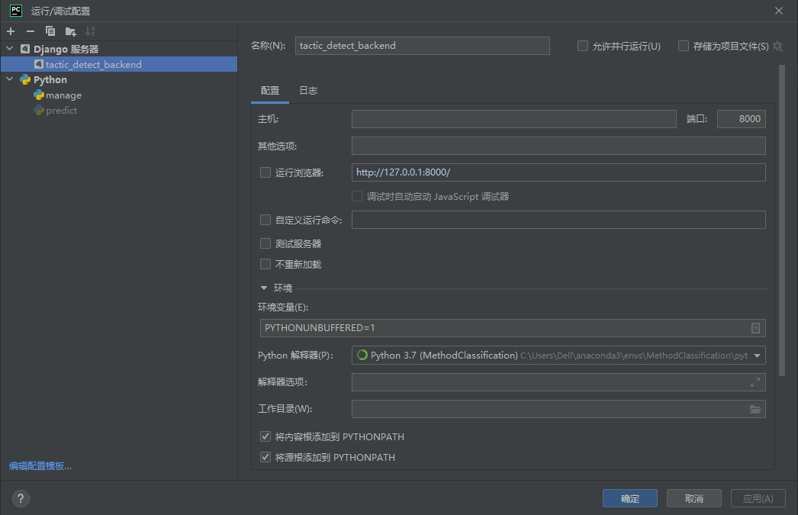frontend and it will show :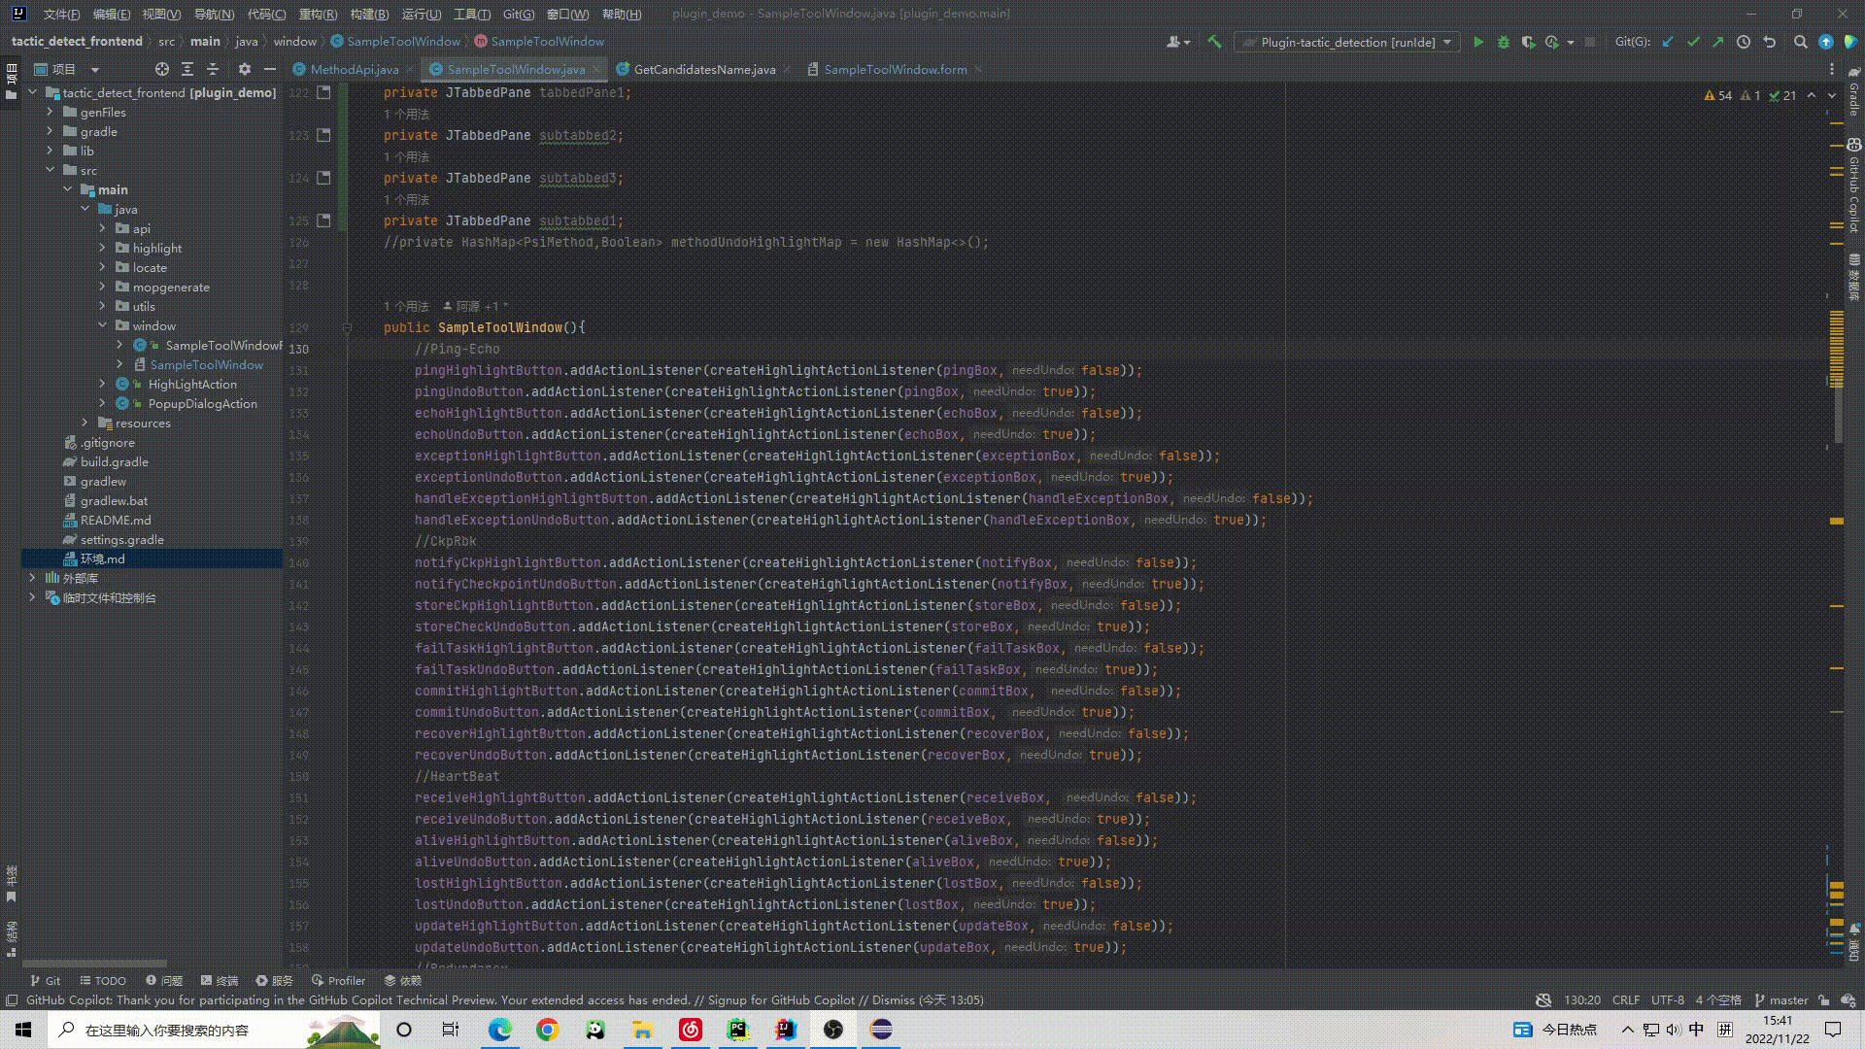

2-3 Use the tool

At the end of the article, we provide a Java code with PingEcho tactic.

First of all, run the code.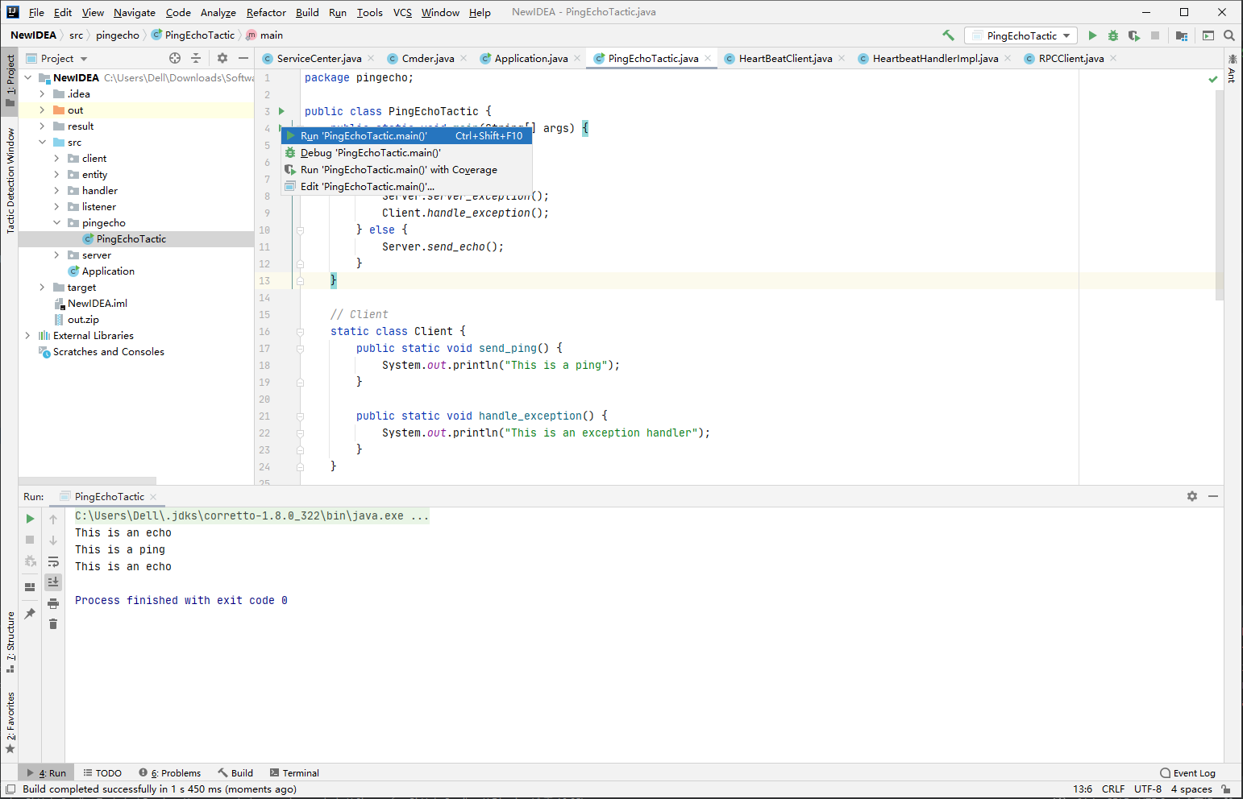

Secondly, checkout to the Tactic Detection Window.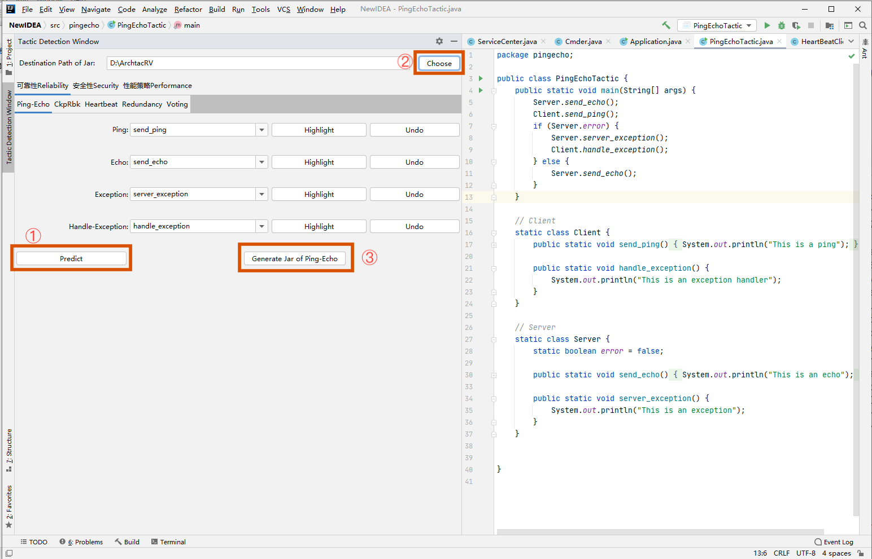

Then, we click the Predict button and tool will show the recommend tactic name, and we choose the Destination Path of Jar then click Generate Jar of Ping-Echo. We will get the Ping-Echo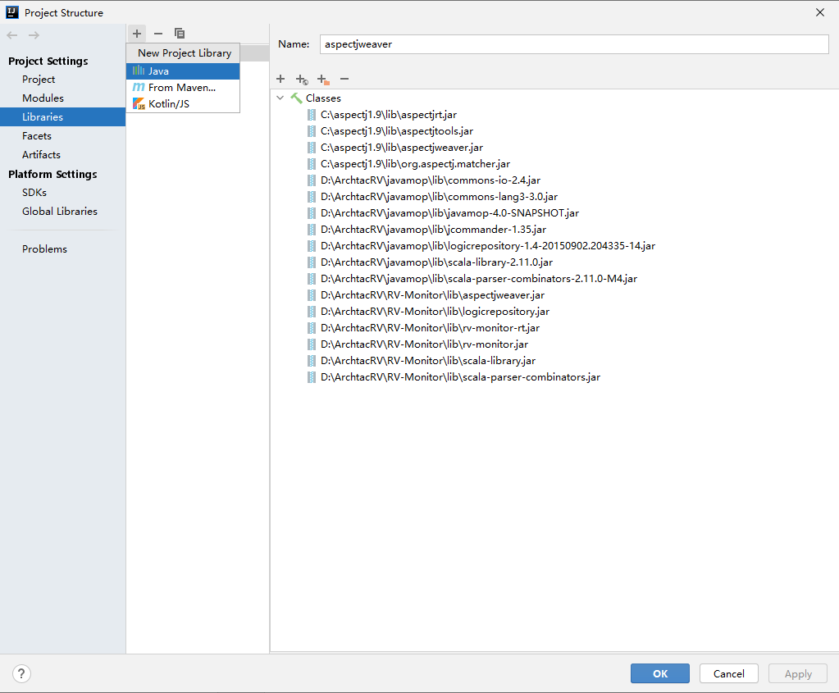 jar in destination of path.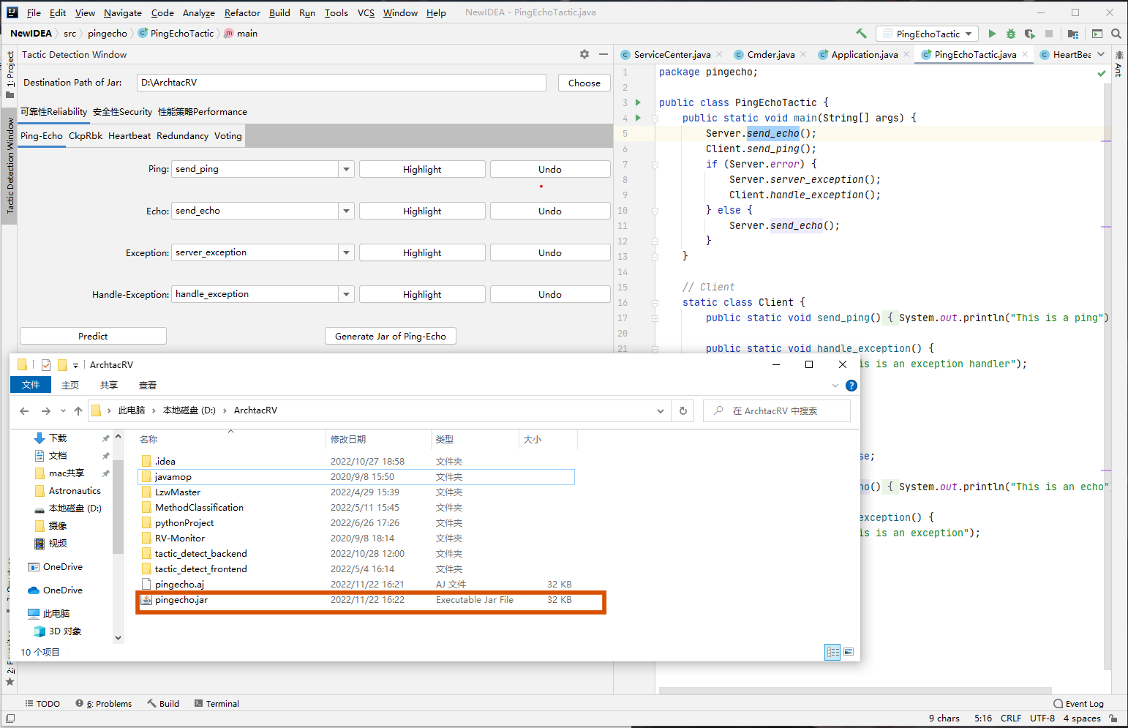

Then, we will add the external jars add to our IDEA. Open File -> Project Structure -> Libraries -> add Java Library. Add all we need jar in the library.

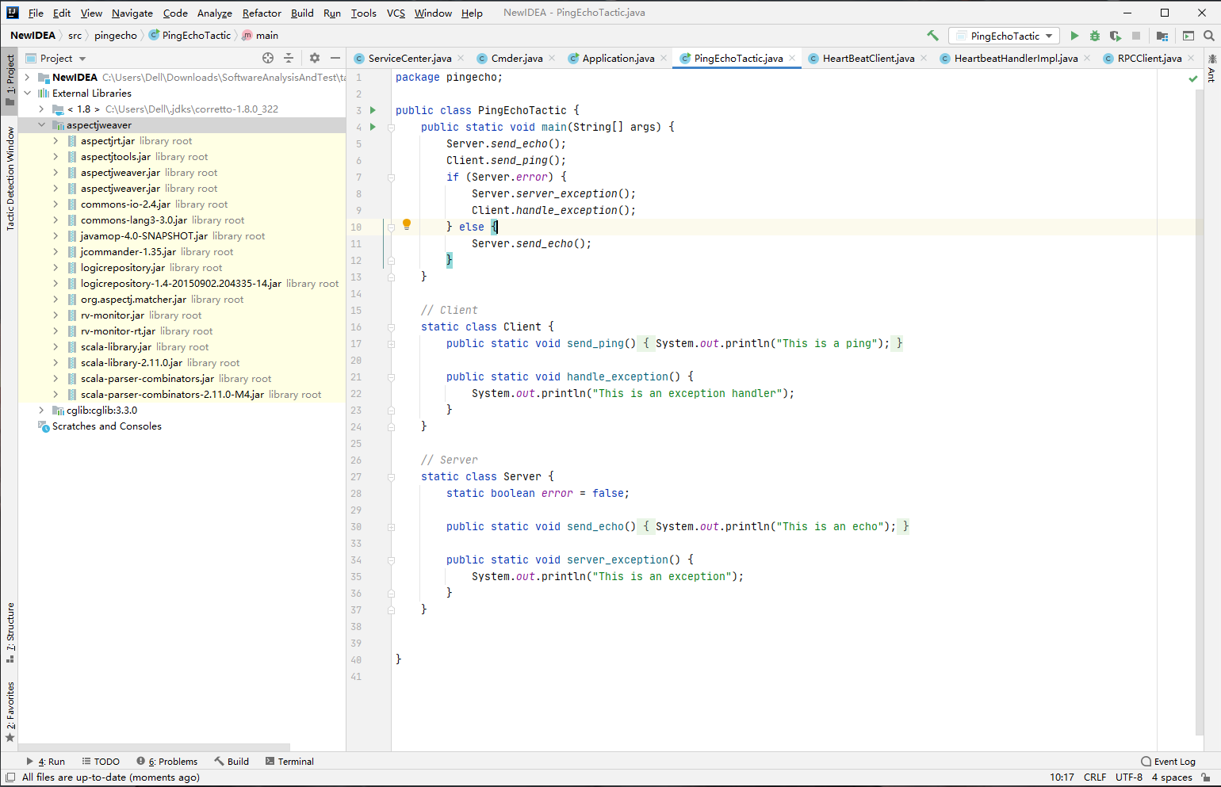

Finally, we add “-javaagnet: the path of jar” to VM options, and run code.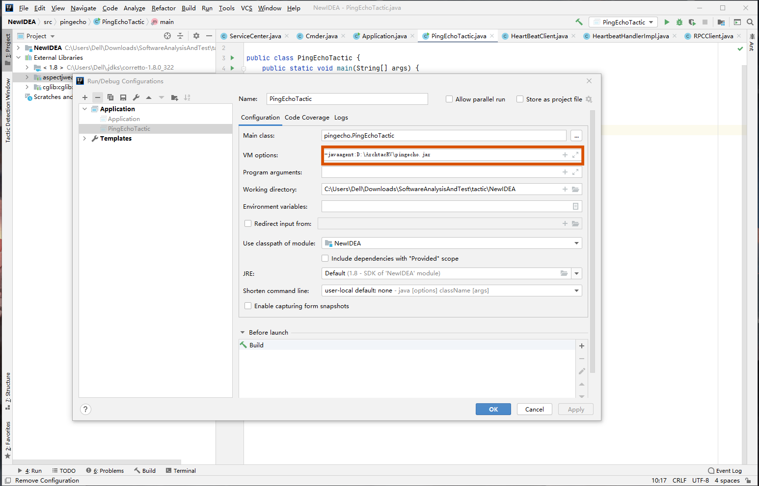

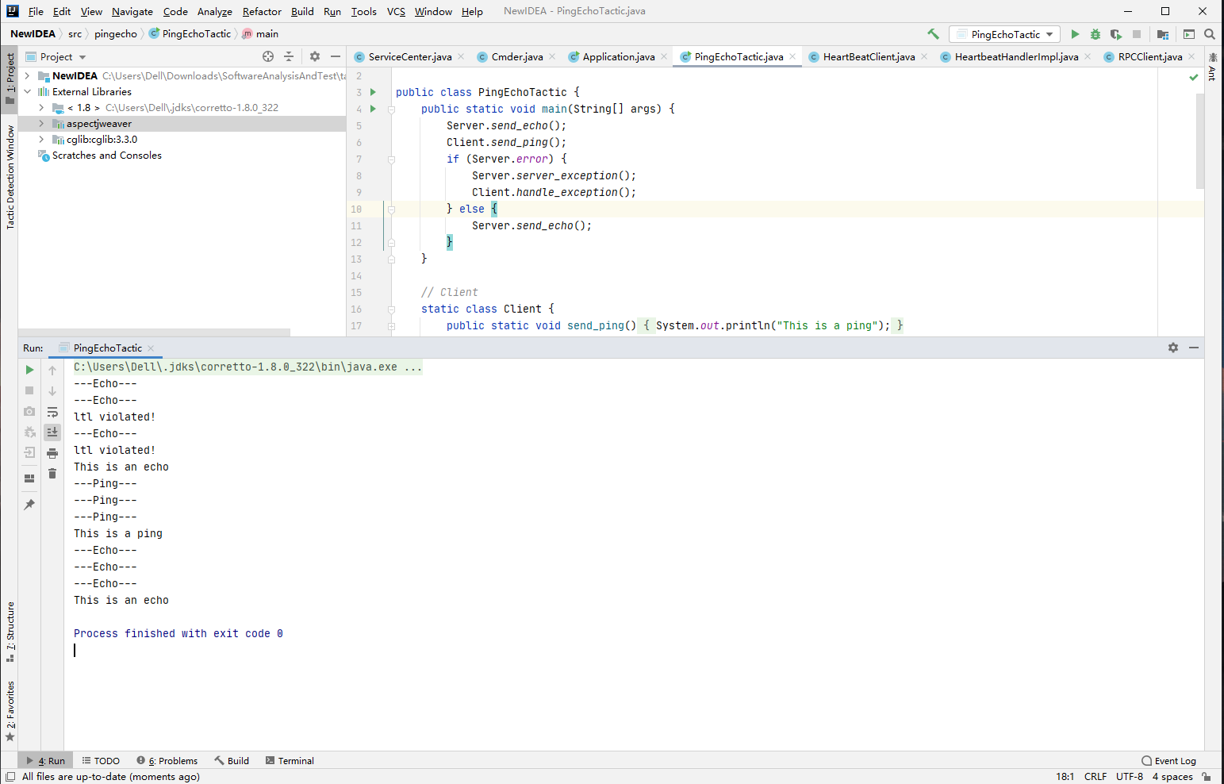

Thank you for using our tools and wish you all the best.